Machine Setup Guide

Machine Setup Guide

(may be subject to change in the future)

Here are the steps that I use to setup machine learning on a machine. My method, however, involves installing Anaconda as a Python interpreter. If you already have a Python installation or preferred way to install Python, my steps would only apply really for Anaconda due to the use of the conda package manager.

DISCLAIMER:  
This guide is primarily written for Nvidia, as TensorFlow support works out of the box. Recent AMD GPUs are also supported if you are running Linux, but your mileage may vary.

* **NVIDIA**: Check the CUDA capability of your graphics card [here (Links to an external site.)](https://developer.nvidia.com/cuda-gpus). You are good to go if your card has CUDA capability of 3.5 or higher. **Lower than this is not supported by TensorFlow.**
  + Not sure where to look on the website? Check the link and scroll down to "CUDA-Enabled GeForce and TITAN Products"
  + Not sure what Nvidia graphics card you have?
    - **Windows**
      * Go to your desktop, right click, and hit "NVIDIA Control Panel." A window should pop up.
      * On the top most toolbar go to Help -> System Information
      * You should see your graphics card in the window as underlined in red in this picture:  
         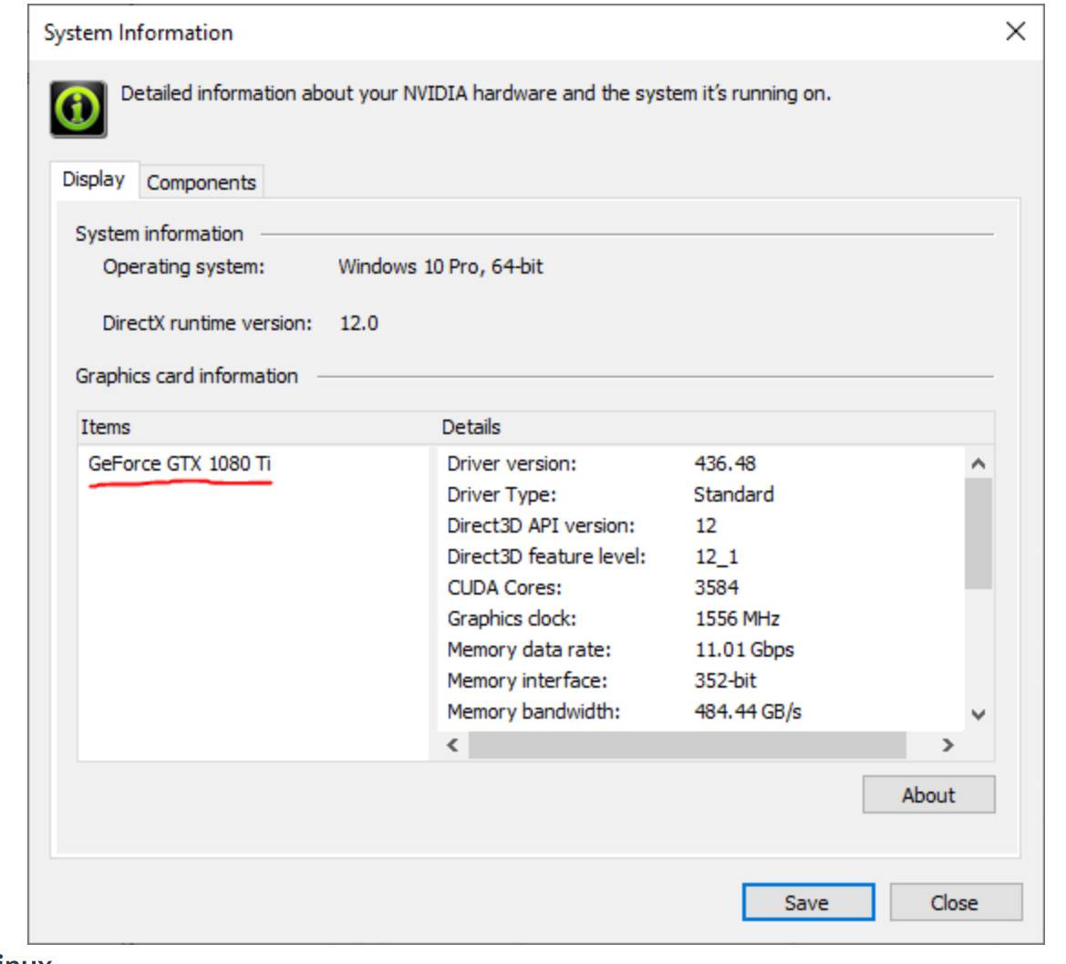
    - **Linux**
      * If you have the proper NVIDIA Drivers installed, run nvidia-smi in the terminal
      * You should see your graphics card in the terminal as underlined in red in this picture (not my screenshot):
      * 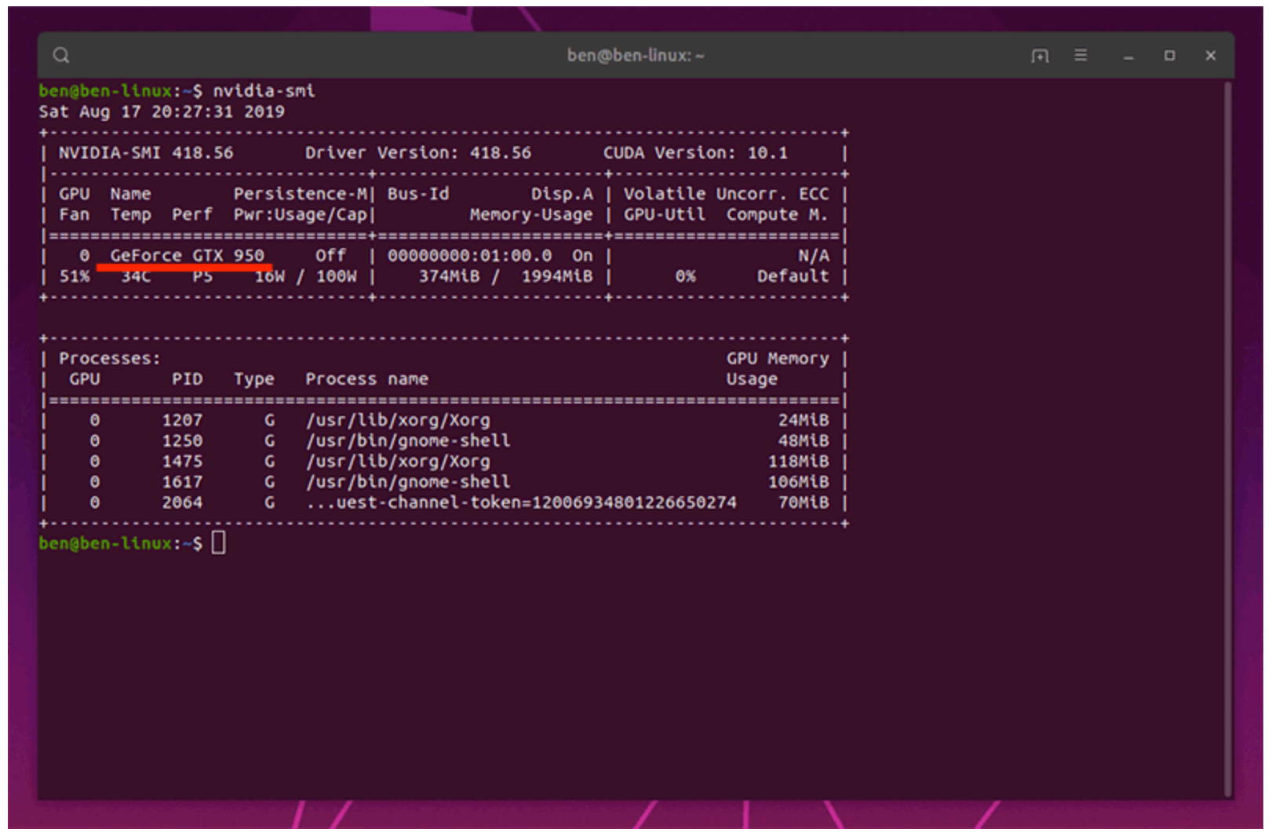

**Additional Information**  
We will be allowing the use of **any** IDE or editor that you prefer for Python programming. Personally, I would recommend PyCharm, VSCode, or Atom. Do ***NOT*** use Jupyter Notebook for training or debugging! It is much, much slower for machine learning in both training and prediction. It is fine to use if you would like to show your *final* results.

Windows (only NVIDIA GPUs supported)

1. Install the latest version of Anaconda [here (Links to an external site.)](https://www.anaconda.com/distribution/)
2. [(Links to an external site.)](https://www.anaconda.com/distribution/)Once it has installed, open the Anaconda Powershell Prompt by searching it on your start menu.
3. Making an environment for this class is **highly** recommended, but may be skipped.
   1. Enter conda create -n IntroML python==3.7 to create a new environment. You will be asked to type y/n to confirm your changes.
   2. Enter conda activate IntroML to activate the environment
4. For Windows, only NVIDIA GPUs are supported. Install the GPU version of TensorFlow using conda install tensorflow-gpu
5. Install the other Python libraries in the same Anaconda Powershell Prompt: pip install scikit-learn pillow talos

Linux (NVIDIA supported, AMD also supported but YMMV)

1. Install the latest version of Anaconda [here (Links to an external site.)](https://www.anaconda.com/distribution/). You should receive a .sh file to run as executable in your terminal, which would be compatible with pretty much all Linux distributions.
2. Once it has installed, open your terminal.
3. Making an environment for this class is *highly* recommended, but may be skipped:
   1. Enter conda create -n IntroML python==3.7 to create a new environment. You will be asked to type y/n to confirm your changes.
   2. Enter conda activate IntroML to activate the environment
4. Proceed with these instructions depending on the brand of GPU you possess:
   * 1. **NVIDIA**: Install the GPU version of TensorFlow using conda install tensorflow-gpu
     2. **AMD**: Install the official ROCm build through instructions found [here (Links to an external site.)](https://rocm.github.io/tensorflow.html)
5. Install the other Python libraries in the same terminal: pip install scikit-learn pillow talos